
INTERNATIONAL CYBERSECURITY AND DIGITAL FORENSICS ACADEMY

ASSIGNMENT

Assignment Title: Digital Forensics Case Handling, Autopsy and Sleuth Kit Analysis
Student Name: Ahmad Zubairu Garba
Student ID: 2025/FWSD/11463
Course Title: Basic Computer Skills for Digital Forensics
Course Code: SBT-DF202
Instructor: Aminu Idris

August 27, 2026
SECTION A: THEORETICAL OVERVIEW
1. DIGITAL INVESTIGATION PROCEDURES & EVIDENCE HANDLING
Digital forensics investigation relies on strict procedural controls to ensure evidence admissibility in a court of law:
Identification: Locating physical and digital media that may contain potential evidence.
Preservation: Isolating evidence to prevent alteration or contamination. The primary rule is to never analyze original evidence; work exclusively on bit-stream forensic copies.
Acquisition: Creating bit-stream copies of original storage media while calculating cryptographic hashes (MD5) to verify data integrity.
Chain of Custody: Documenting every individual who handled the evidence, the exact timestamp of transfer, storage conditions, and verification hash values.

2. THE SLEUTH KIT (TSK) ARCHITECTURE
The Sleuth Kit (TSK) is a C library and collection of command-line tools designed for file system and media analysis. TSK organizes operations across distinct functional layers:
- Disk Image Layer (img_stat, img_cat): Processes raw and container image formats.
- Volume System Layer (mmls, mmstat): Analyzes volume structures and partition tables (e.g., DOS, GPT).
- File System Layer (fsstat): Displays file system metadata, cluster sizes, layout, and structural boundaries.
- Metadata Layer (istat, icat, ils): Analyzes structural metadata pointers (Inodes in UNIX/Linux, MFT entries in NTFS, Directory Entries in FAT).
- Data Unit Layer (blkcat, blkls, blkstat): Reads raw clusters and sectors directly.
- File Name Layer (fls, ffind): Maps file and directory names to their corresponding metadata addresses.

SECTION B: PRACTICAL LAB EXECUTION & EVIDENTIARY ANALYSIS
TASK 1: WORKSPACE CREATION & EVIDENCE VERIFICATION
PART A: WORKSPACE PREPARATION
To maintain forensic isolation and adhere to evidence handling guidelines, a dedicated lab directory structure was created before beginning analysis.
The command mkdir usb created a dedicated working directory. The directory was accessed using cd usb, and the authorized forensic image Ch01InChap01.dd was downloaded using wget.
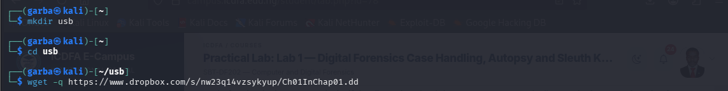
PART B: INITIAL EVIDENCE VERIFICATION AND HASHING
Before performing any forensic recovery, the file size and MD5 checksum of Ch01InChap01.dd were computed to record baseline evidence integrity.
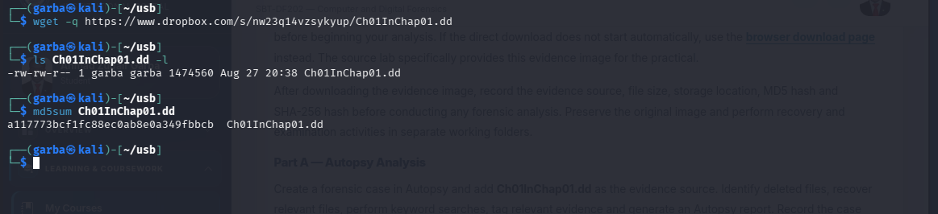
The command ls Ch01InChap01.dd -l verified the exact byte size, and md5sum Ch01InChap01.dd generated the cryptographic hash.
MD5 Verification Hash: a117773bcf1fc88ec0ab8e0a349fbbcb

PART C: MINI CHAIN-OF-CUSTODY WORKSHEET
Field | Evidence Entry
Case Title | Digital Forensics Practical Lab 1
Item ID | Item 001
Evidence Description | Raw Disk Image (Ch01InChap01.dd)
File Size | 1474560 bytes (1.5 MB)
Storage Location | /home/garba/usb/Ch01InChap01.dd
Verification MD5 | a117773bcf1fc88ec0ab8e0a349fbbcb
Verification SHA-256 | 3ce8053e4f3d9c8ab98b3aadb2480685efb8e4980d34297b83bd5a09b1a7b122
Acquired By | Ahmad Zubairu Garba
Acquisition Date | August 27, 2026
TASK 2: SLEUTH KIT FILE SYSTEM & IMAGE METADATA ANALYSIS
PART A: IMAGE METADATA EXAMINATION (img_stat)
img_stat was executed to inspect the container image format properties.
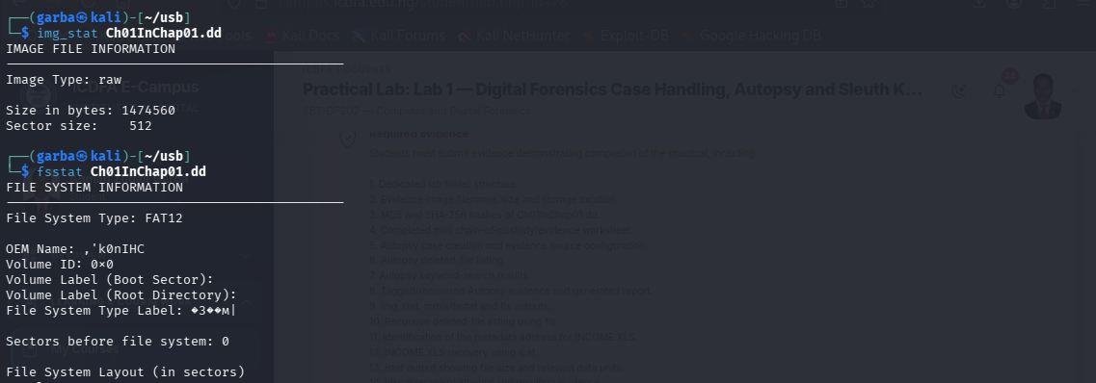
The command img_stat Ch01InChap01.dd displayed the image format as raw, confirming a sector size of 512 bytes and total size of 1474560 bytes.
PART B: FILE SYSTEM DETAILS (fsstat)
fsstat was executed to display the file system layout and volume metrics.

The command fsstat Ch01InChap01.dd identified the file system as FAT12. It showed that the data area spans sectors 19–2879, the root directory occupies sectors 19–32, and the cluster area spans clusters 2 through 2848.
PART C: DIRECTORY LISTING & DELETED ENTRIES (fls)
Directory structures and deleted files were enumerated using fls and fls -d.

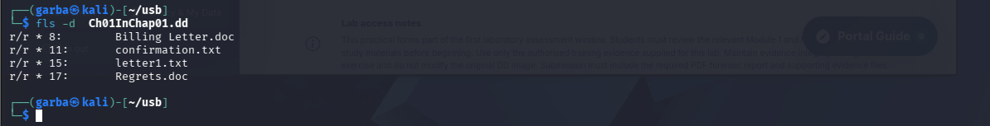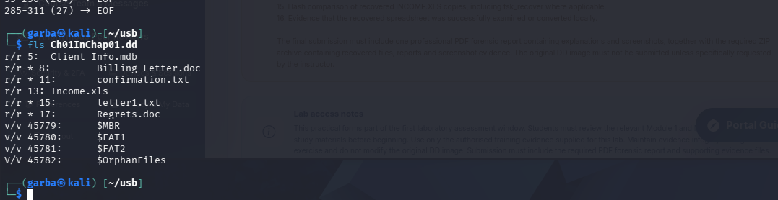
The command fls Ch01InChap01.dd listed all directory entries, revealing target file Income.xls at metadata address (inode) 13. The command fls -d Ch01InChap01.dd filtered the directory to display deleted entries marked with *, identifying deleted files such as Billing Letter.doc (inode 8), confirmation.txt (inode 11), letter1.txt (inode 15), and Regrets.doc (inode 17).
TASK 3: RECOVERY AND METADATA EXAMINATION OF DELETED EVIDENCE
PART A: DELETED FILE EXTRACTION VIA INODE (icat)
icat was used to recover deleted file contents using metadata pointers.
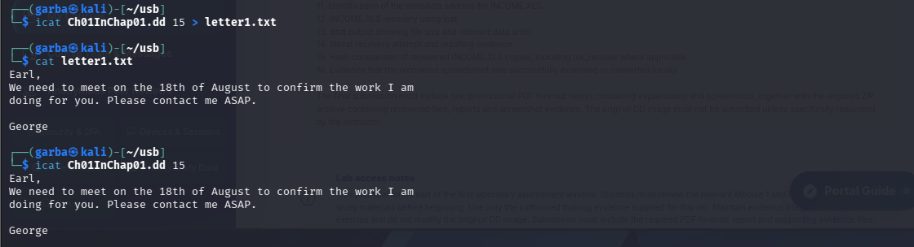
The command icat Ch01InChap01.dd 15 > letter1.txt extracted the raw data associated with inode 15 without requiring the original filename. The command cat letter1.txt displayed the recovered message content from George to Earl regarding an August 18th meeting.
PART B: METADATA STRUCTURE INSPECTION (istat)
istat was executed on inode 15 to inspect metadata properties and cluster allocations.

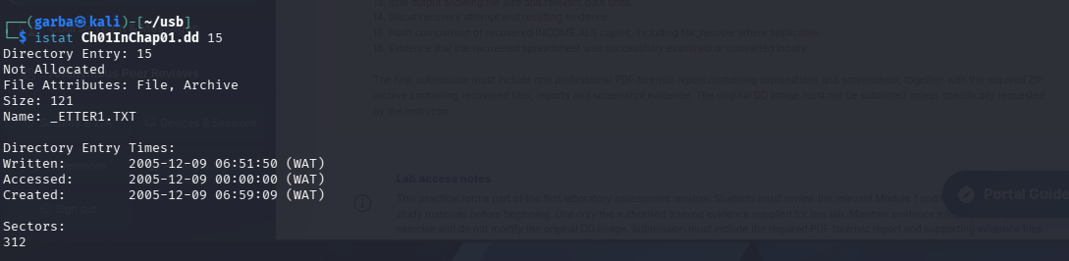
The command istat Ch01InChap01.dd 15 confirmed the file allocation state as Not Allocated (deleted), listed a file size of 121 bytes, and verified that its content resides on sector 312.

PART C: DATA UNIT EXTRACTION AND HEX DUMP (blkcat & blkls)
Raw data units were inspected directly using blkcat and blkls.
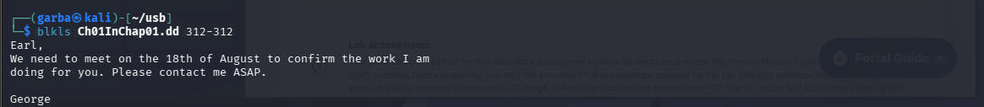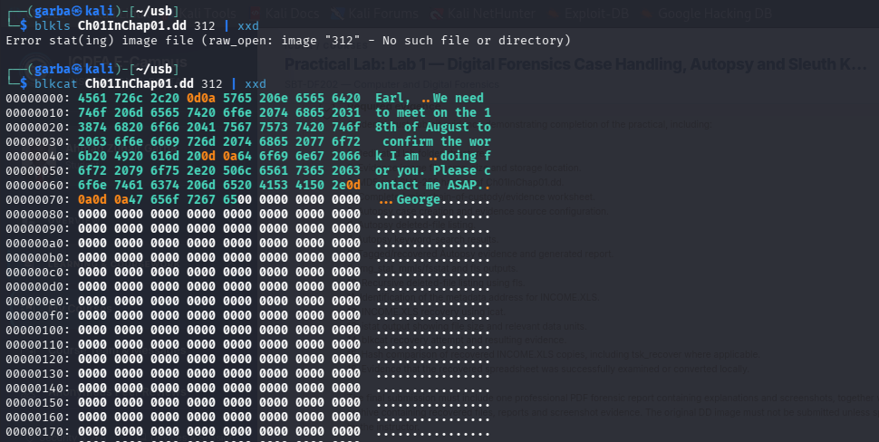
The command blkcat Ch01InChap01.dd 312 read sector 312 directly from the disk image. blkls Ch01InChap01.dd 312-312 extracted unallocated space metrics for that sector. Pipe-ing blkcat to xxd displayed sector contents in hexadecimal format, confirming ASCII text and trailing zero-padding up to the sector boundary (0x1ff / 512 bytes).
TASK 4: TARGET ANALYSIS & RECOVERY OF INCOME.XLS
PART A: TARGET METADATA ANALYSIS (istat)
istat was executed specifically on Inode 13 to analyze metadata structure and sector mappings for INCOME.XLS.
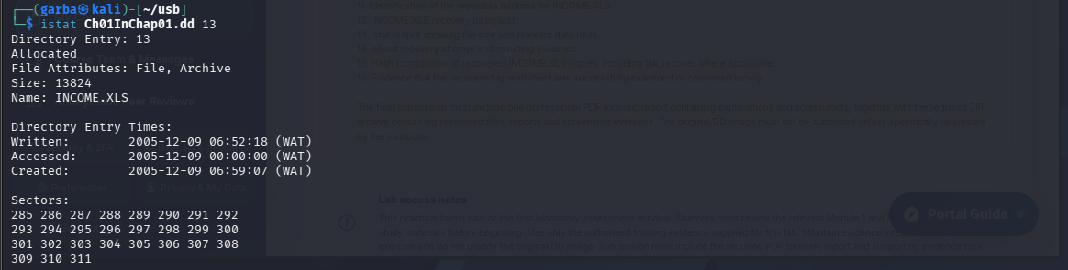
The command istat Ch01InChap01.dd 13 displayed metadata properties for INCOME.XLS:
- Directory Entry: 13
- Allocation Status: Allocated
- File Size: 13824 bytes
- Sectors Allocated: 285 286 287 288 289 290 291 292 293 294 295 296 297 298 299 300 301 302 303 304 305 306 307 308 309 310 311 (A contiguous sequence of 27 sectors).
PART B: LOOP-MOUNTING RAW IMAGE (losetup)
The raw image was loop-mounted into the Linux kernel to access file system contents directly via local file management tools.
The command sudo losetup --partscan --find --show --read-only Ch01InChap01.dd created a read-only loop device assigned to /dev/loop0 (and later /dev/loop1 on re-execution). The --partscan option scanned for partitions, while --read-only preserved evidence integrity.
PART C: LOCAL FILE SYSTEM MOUNT & EXAMINATION
The mounted 1.5 MB volume was opened in the Thunar File Manager and terminal environment to verify local access.

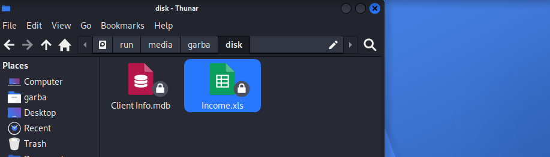
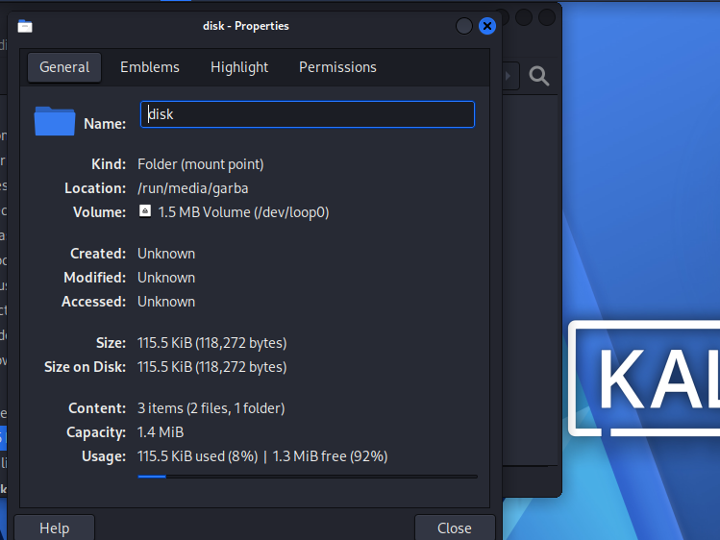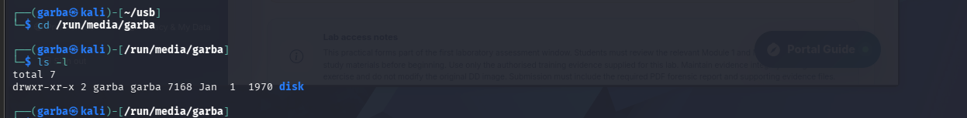Opening the desktop volume mounted at /run/media/garba/disk displayed target files Client Info.mdb and Income.xls. Right-clicking properties in Thunar confirmed a total file system usage of 115.5 KiB (118,272 bytes) formatted as msdos (FAT12). Running ls -l in terminal confirmed directory access permissions and mounting under /run/media/garba/disk.
TASK 5: ADVANCED RECOVERY, HASH COMPARISON & EVIDENCE VERIFICATION
PART A: SHA-256 IMAGE INTEGRITY VERIFICATION
The SHA-256 cryptographic hash of the evidence image was calculated to fulfill evidence baseline requirements.
The command sha256sum Ch01InChap01.dd calculated the SHA-256 digest: 3ce8053e4f3d9c8ab98b3aadb2480685efb8e4980d34297b83bd5a09b1a7b122.

PART B: RECURSIVE DELETED FILE LISTING (fls -r -d)
A recursive listing of deleted directory entries was generated to fulfill deliverable requirements.
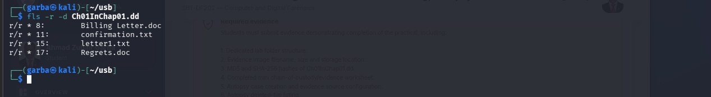
The command fls -r -d Ch01InChap01.dd searched recursively (-r) for deleted files (-d). Output confirmed deleted files across root directory entries:
PART C: MULTI-VECTOR RECOVERY & HASH INTEGRITY MATRIX
INCOME.XLS was recovered using three distinct forensic techniques (icat inode extraction, blkcat sector concatenation loop, and direct read-only loop mount) to perform verification hashing.
[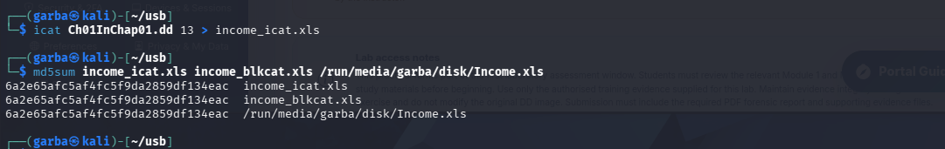
The command icat Ch01InChap01.dd 13 > income_icat.xls extracted the file via inode 13. The for loop appended data units from sector 285 to 311 into income_blkcat.xls.

